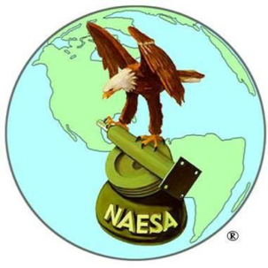  “In the Public Interest” | NAESA International | 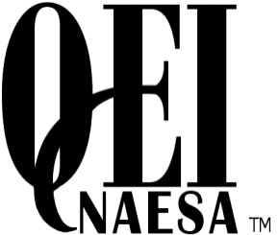
National Association of Elevator Safety Authorities
PO Box 4367
Mankato, MN 56002
Phone: 360-292-4968 Fax: 360-292-4973
Web: www.naesai.org

NAESA International Inspector Trainee Program

Start Date: January 21, 2025

End Date: December 15, 2025

For more information on this new program, please visit https://naesai.org/Education

